**Global Terrorism Report – Tableau**

Created an extensive storyboard with multiple dashboards that analyzed global terrorism data from 2000 to 2020.

Described the data by country, highlighting the number of fatalities in each nation.

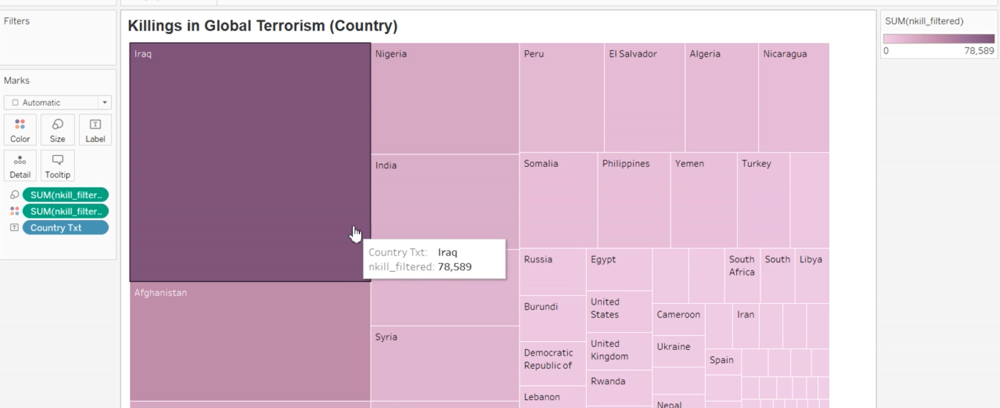

Analyzed the data using line charts for different regions, illustrating the number of killings per year.

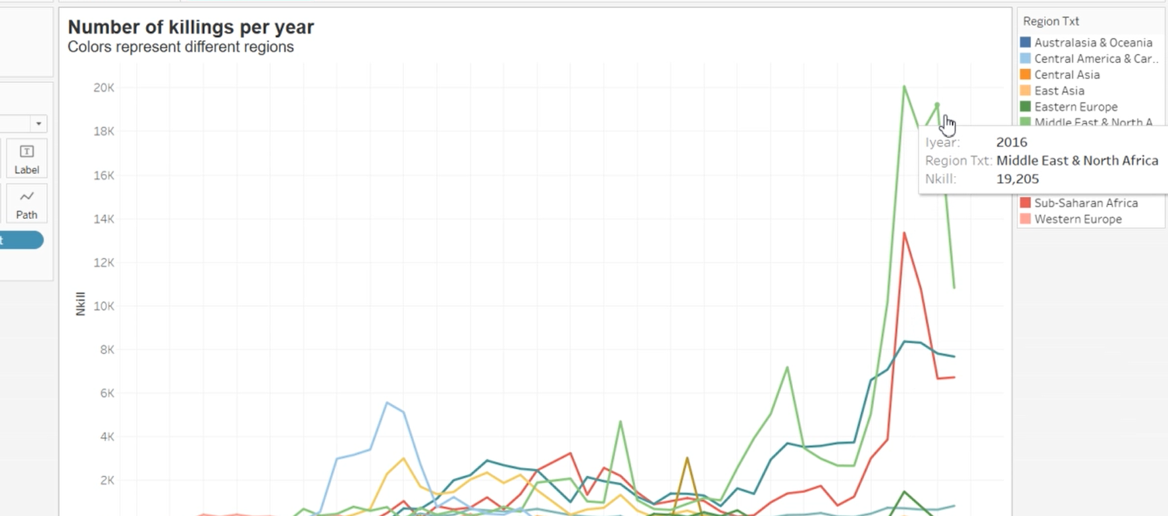

Utilized maps to highlight target areas, displaying the number of killings and wounded individuals, along with latitude and longitude to describe the geographical context.

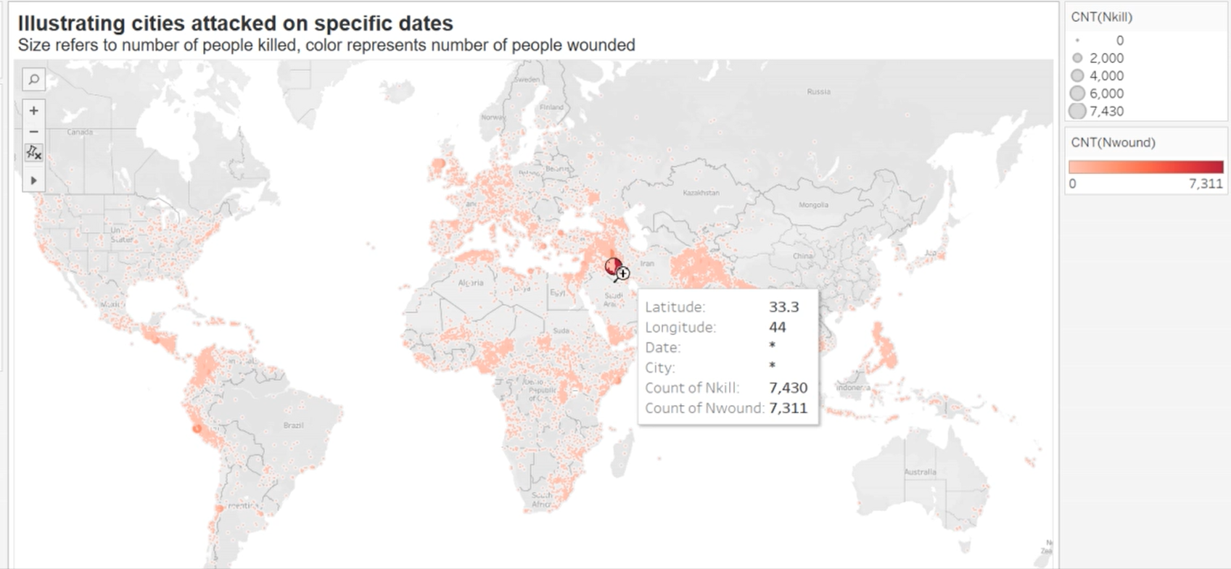

Displayed various perpetrator groups and highlighted the most common ones.

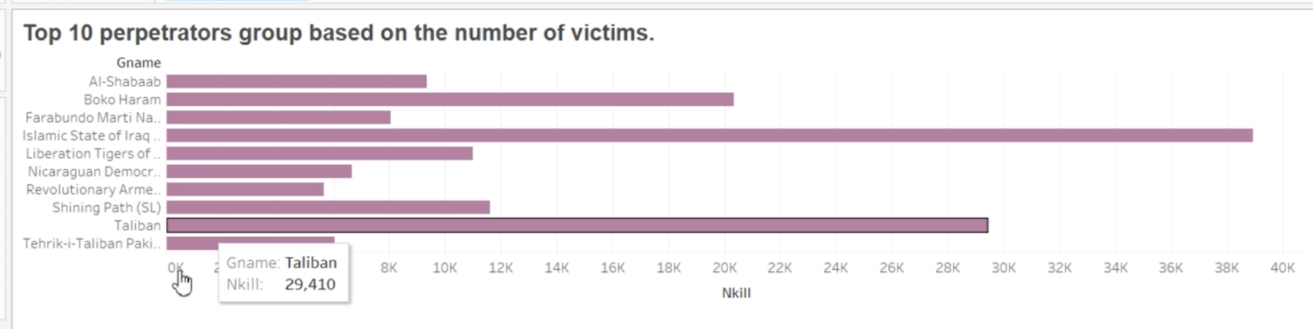

Analyzed weapon types and subtypes across different regions.

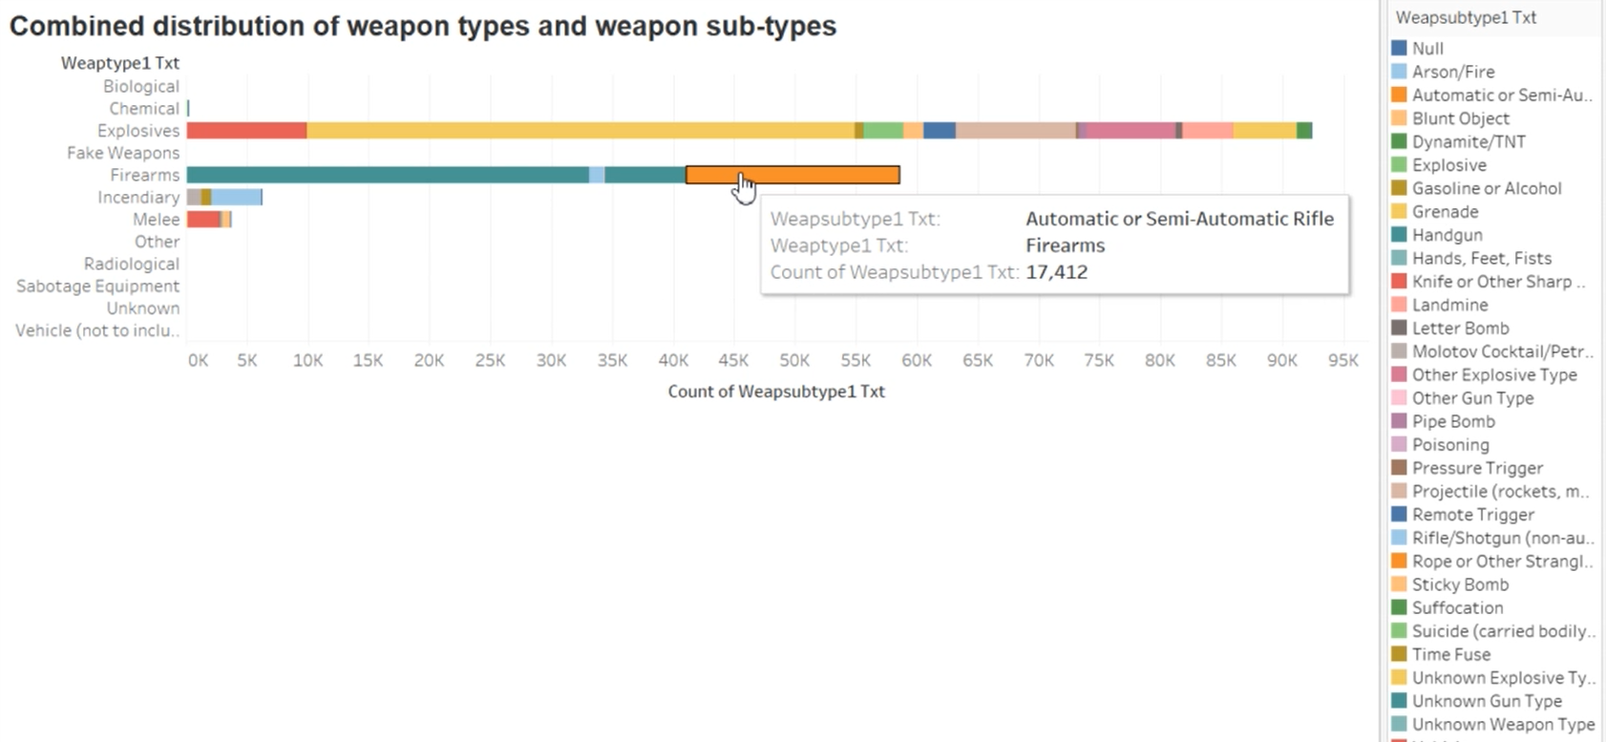

Used pie charts to display the distribution of weapon types.

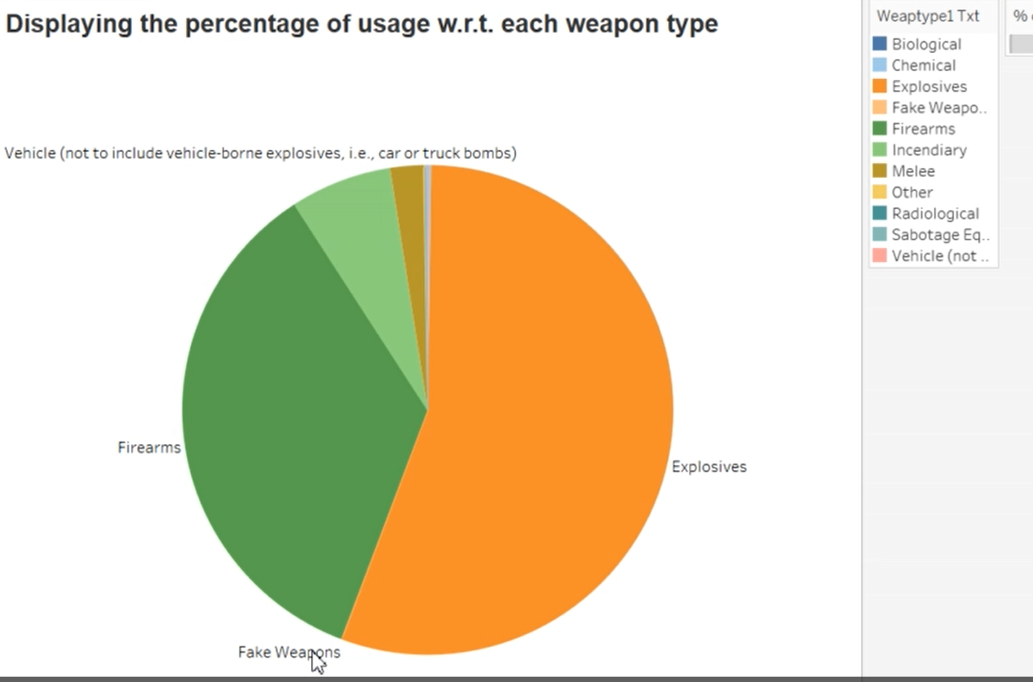

Created a comprehensive storyboard by combining all individual dashboards into one unified report.

